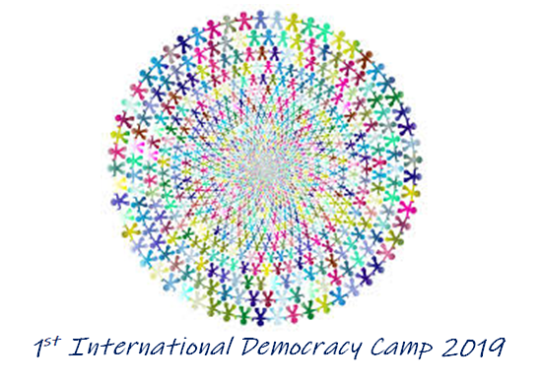
PRESS RELEASE
The 1st International Camp of Democracy in Andros, which took place from the 29th of June till the 4th of July 2019 was completed successfully. It was attended by 27 students and trainers from Greece, England, Bulgaria, Qatar and the United States. The event took place in Corthi, Andros in a context of excellent hospitality by the residents and valuable help from local agencies, which contributed to a truly memorable experience.
The students' daily engagement with the nature and culture of the island (excursions to Chora and beaches, visits to museums, traditional nights, information from Life Andros Park about endangered species of Andros etc.), culminated into the main camp activity, which was the participation in a variety of daily three-hour experiential personal development workshops: rhetoric and public speaking, communication principles, intercultural culture, team building activities, leadership by classical writers, theatetrical performance techniques, participation in MUN, conflict resolution and restorative justice, literature and leadership, creative thinking techniques. Participants attended two workshops daily depending on their interests and needs. It is noteworthy that recent school graduates as well as alumni of the co-current 3rd Rhetoric and Democratic Education Camp (further info about this camp can be found here: https://openyourmindcamp.weebly.com) also showed great interest in attending workshops with academics and experts from the 1st International Democracy Camp.
In a successful and well-attended event, hosted by the Andrion Club (www.andrionclub.gr), which took place at the Municipal Theater of Chora entitled "Preparing the Citizens of Tomorrow", the aims, goals and structure of the 1st International Democracy Camp was presented, and the event was ended with a keynote lecture offered by Dr. Norman Sandridge, who is an Associate Professor of Classics at Howard University in Washington, DC. (https://profiles.howard.edu/profi…/…/norman-bishop-sandridge)
The rationale of the 1st International Democracy Camp is based on the observation that modern active citizens are expected to develop and utilize democratic culture skills as outlined in the Competences for Democratic Culture (https://www.coe.int/en/web/education/competences). Taking initiatives and consciously participating in civil society, while cultivating the consciousness of a citizen of the world are seen as indispensable prerequisites for improving the ever-changing world and facing a variety of challenges. In addition, the experiential approach to concepts and values, ​​such as 'democracy', 'mutual respect', 'active participation in the community', 'cooperation' is a unique way of realizing their importance for the harmonious and fruitful coexistence of citizens and peoples in general. The international profile of the camp will be enhanced in the coming years by making multiculturalism a key experiential axis.
The 1st International Democracy Camp is the outcome of co-operation between the Hellenic Union for the Promotion of Rhetoric in Education and the Andrion Club, which since November 2018 has strongly supported the creation of rhetorical groups and the training of the island-based teachers in teaching rhetoric. Co-organizer of the camp has also been the Prefecture of the South Aegean. Supporters of our effort to organize a successful and highly stimulating camp have been the University of Athens Postgraduate Studies Program "Rhetoric, Human Sciences and Education", the European Community for Democratic Education - Branch of Greece (EUDEC-Greece), SAFIA - Student Association for International Affairs, "Arrival" - Model of the Hellenic Parliament and Virtual Trials "Protagoras" and CommonSpeak "ANDROS". Special thanks go to Zefi Sorotou for her valuable help. Major sponsors of the camp were FAST FERRIES, the Moustakeio Foundation and the company Proteus - Social Innovation and Development. The sponsors that supported the promotion of the event were Radio station Asteras 92, the website Efiveia.gr and the company Haidemenos SA. Catering sponsors were the company "Sklavenitis" and the hotels in Corinth "Augustis Suites", "Hotel Korthion" and "Villa Korthi". Thanks to H. Baloyiannis CTN Andros (Andros' Cycladic Tourism Network) and Explore Andros (https://exploreandros.gr/) for their valuable assistance in preparing the hospitality-related activities, the Primary School of Corthi for hosting all our workshops, the Corthi Women's Association for organizing the excellent and memorable farewell gala dinner, as well as all Corthi and Chora restaurants for offering special discounts to all participants. In particular, we thank the Vice Mayor and Chairman of the School Committees, Mr. I Skordos, Ms. V. Routis, the teacher G. Tiniakos for their valuable assistance and our participant Nayden Yotov for offering a theatrical workshop.
The team of outstanding scholars who offered workshops on a voluntary, pedagogical basis consisted of the following (titles as listed on the official English-language website):
Dr Thanasis Nakas, Professor Emeritus of Linguistics (University of Athens, Greece)
Dr Tzina Kalogirou, Professor of Modern Greek Literature and Literature Teaching (University of Athens, Greece)
Dr. Norman Sandridge, Associate Professor of Classics and Leadership (Howard University, Washington, DC)
Dr Irene Theodoropoulou, Associate Professor of Sociolinguistics and Discourse Analysis (Qatar University, State of Qatar)
Dr Elena Koltsaki, Attorney at law & accredited mediator (Hellenic Ministry of Justice)
Dr Markos Perrakis, Leadership Development & Process Facilitator, Trainer, Psychologist, Speaker
Ms. Valia Loutrianaki, Phd cand. (University of Athens, Greece), educator of greek language, rhetoric and creative thinking, president of the Hellenic Association for the Promotion of Rhetoric in Education
Ms. Mary Marin, Phd cand. (University of Carlfield, USA), educator of English language, MUN mentor
The organizing team that oversaw the preparation and implementation of the camp consisted of the three general coordinators, the president of the Rhetoric Association, Ms. V. Loutrianaki, the Associate Professor at Qatar University, Dr. I. Theodoropoulou, and the president of the Andrion Club, Mr. D. Kokkinis, as well as the Promotion and Communication Specialist, Ms. O. Avdis, and the philologist and PhD candidate at the University of Peloponnes, Ms. P. Giannopoulou. The editing of the audiovisual material of the camp was undertaken by Ms. M. Marin.
The completion of the 1st International Camp of Democracy inaugurates a new cycle of substantive knowledge and experiential experiences with emphasis on skills development and personal development. The positive feedback and enthusiasm of the participants, trainers and the local community heralds the continuation of the camp, which is expected to become a well established institution in the future.
https://internationaldemocracycamp-greece.weebly.com

